The Great Patriotic War
and
My Great - grandfather

By Victor Arutin
ICS3-23B

Alexander Fedorovich Mitin (1908 - 1973)
To be honest, it's hard for me to tell a story about my great-grandfather. He went through so much - before the war, after the war, and of course, during the Great Patriotic War. The events he described...sometimes they made you laugh, sometimes shudder in horror, sometimes cry. But I'll try. And history will begin long before the war...
My great-grandfather was born in 1908. He missed the revolution and the Civil war, and he did not regret about that. He had a simple happy life before the war - home, family, job.
All that ended on the 22-d of June 1941.

1941
My great-grandfather was called up to the army. As a first-class engineer, he was assigned to the emerging 134th separate motorized engineer battalion.
The battle path began in August, in the Demyansk district. The battalion covered the withdrawal of infantry units. According to my great-grandfather, they paved roads for their troops and mined or immediately blew them up to prevent the Germans from advancing. Nevertheless, they were especially good at paving them - they carried concrete blocks on their shoulders. Once they organized a "socialist competition" - to pave the road through the swamp faster. The prize was a pot of stewed fruit. The great-grandfather's company worked chest-deep in water, but won!

In September 1941, Soviet troops were encircled at Demyansk. Unfortunately, the134 battalion, also got into that pocket. The Red Army attempted to break through the encirclement. It (and, accordingly, the 134 battalion) succeeded, but with heavy losses.
After the Demyansk pocket, the battalion was transferred to Moscow. My great-grandfather had visited it many times - but many of his companions had not, and he was happy to describe "the charms of the big ring" to them.
While the battalion was mining roads around Moscow, one of the mines in the rear went off. When the soldiers got there, they saw a squirrel, scared and small. As it was running across the road, a mine accidentally exploded nearby, and he stood still startled. The squirrel was sheltered, named Boris and became a kind of mascot of the battalion.
1942
After the battle of Moscow, the battalion was transferred to the Valdai lakes. There it remained for a long time-until the beginning of 1943. The Red army made attempts to liberate Demyansk - in such cases, the battalion cleared existing roads, built new ones, and if the offensive was not successful, did the opposite - mined the roads and, when possible, destroyed them.
There were incidents. For example, one summer night, the battalion was attacked by... bears. Everything was quiet. And they managed to reach the kitchen, when squirrel Boris noticed them and woke up the cook, who tried to scare them away with a ladle. Then the soldiers and my great-grandfather pulled themselves up. There was a dilemma - to shoot bears or not. Decided to shoot over their heads. But it did not help. The bears still besieged the kitchen. Several machine gun tracers were fired into the sky. There was no result. The soldiers wanted to fire a mortar, but my great-grandfather dissuaded them and fired a flare. At the sight of it, the bears (having emptied a couple of pots) took to their heels.
They wanted to give Boris a medal, but the colonel, the commander of the battalion, limited himself to writing a grateful acknowledgment. Well, squirrel Boris was also give an extra ration: “for the fight against saboteurs from the Potapochny Regiment of the Special Kosolapian Wehrmacht Division”.
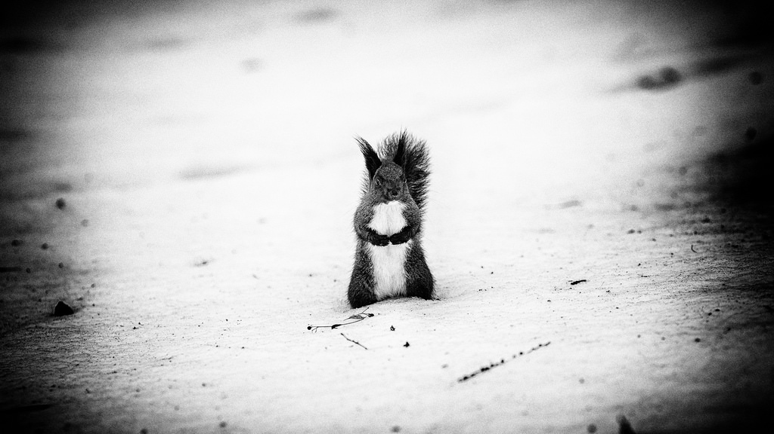
Squirrel Boris – the mascot of the battalion.

1943
In 1943, the battalion finally started to move- after the liberation of Demyansk, my great-grandfather paved the roads in the Novgorod and Pskov regions, in Belorussia. There were especially many events in Belarus:
Once they pulled out a tractor completely submerged into water using a couple of ropes and a tree. My great-grandfather also told me that when in 1941 they left one state farm, he did not finish playing cards with a mechanic. When they returned there in early 1944, the mechanic found him, and they finished the game.
The battalion, in addition to its work, helped the local residents as much as possible - supplied food, built houses and roads, and helped search for saboteurs. The local population did not want to be in their debt and pointed out local roads and trails, the partisans provided intelligence and valuable German captives.

1944
In June of 1944, the 134th separate motorized engineering battalion was converted into the 187th separate engineering-sapper battalion. My great-grandfather continued his service in it, and in the same 1944 his unit was one of the very first to cross the 1941 USSR border and enter the territory of Nazi Germany. Why was it one of the first? My great-grandfather's battalion was mainly engaged in mine clearance - and without mine clearance, armies cannot move on.
My great-grandfather told me a lot about Germany. There he was struck by the fact that the Germans did not consider the Soviet soldiers the embodiment of horror and savagery. If some adults were still afraid, the children were not afraid at all, and helped them: they showed them caches of weapons and supplies of Hitler's saboteurs. Once my great-grandfather with his friend Andrew and the girl called Greta, who found such a hiding place, went to inspect it. While they were examining the cache of weapons, they were visited by "old acquaintances": a pair of bears. At the sight of them my great-grandfather found the strength to joke that they had returned from Valdai. As for weapons they had only 2 pistols with a couple of clips, the bears were definitely hungry, Greta was ready to cry from fear. But lucky they were! There happened to be a German MG42 machine gun with full ammunition in the cache. Just in time! They did not shoot the bears, but the noise from the machine gun was so loud that the animals ran away as fast as they could. When 2 Russians saved a German girl from bears, the residents finally stopped being afraid of them.

1945
The war was coming to its end. The 187th battalion was making its way to Berlin (literally). However, it was not sent to the city, but the battalion went around the city to mine the roads coming from it, and thus cut off the capital from the enemy reinforcements.
According to my great-grandfather, the last "story" that happened to him, was on May 11, 1945, when they celebrated the victory near the forest in the suburbs of Berlin. Everyone was already a little tipsy, and then squirrel Boris again warned everyone - a bear had wandered into the camp again! However, as soon as it saw a crowd of people, it immediately ran away.
They say that people like my great-grandfather are born with a silver spoon in their mouth: he ended the war safe and sound with 5 medals, despite the fact that he had gone through the whole war (from 1941) to Berlin. And I'm glad to have such a great great-grandfather ...

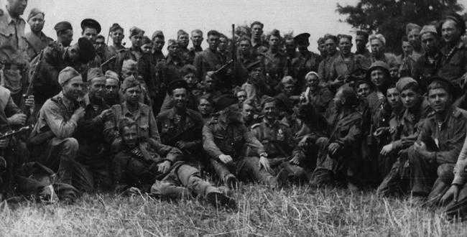
Photo of my great – grandfather`s unit of 134 battalion.

